**Pizza Sales Analysis: Key Metrics and Trends**

--**1) TOTAL REVENUE:**

Calculate the total revenue generated from pizza sales by summing up the values in the "total price" column of the "pizza_sales" table. The result is assigned the alias "total_revenue" for easier reference

**select sum(total_price) as total_revenue**

**from pizza_sales;**

**OUTPUT**

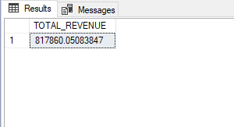

-- **2)AVERAGE ORDER VALUE:**

This code calculates the average order value for pizza sales. It does this by summing up the "total_price" column, which represents the total price of each order, and then dividing it by the count of distinct "order_id" values.

**select sum(total_price) / count(distinct order_id) as average_order_value**

**from pizza_sales;**

**OUTPUT**

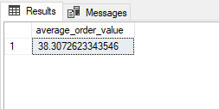

--**3)TOTAL PIZZA SOLD:**

The total number of pizzas sold by adding up the quantities of pizzas from the "pizza_sales" table. The result is labeled as "total_pizza_sold". This query gives a simple and direct approach to finding the overall count of pizzas sold.

**select sum(quantity) as total_pizza_sold**

**from pizza_sales;**

**OUTPUT**

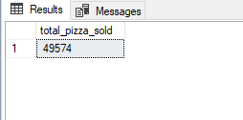

**--4) TOTAL ORDERS**

Count distinct order IDs in "pizza_sales" to get the total unique orders. Result: "total_orders". Efficient query to exclude duplicates and determine unique order count..

**select count(distinct order_id) as total_orders**

**from pizza_sales;**

**OUTPUT**

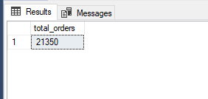

**--5) AVERAGE PIZZA PER ORDER**

Calculates the average pizzas per order by dividing the sum of quantities by the count of distinct orders, providing an accurate result rounded to two decimals.

**select cast(cast(sum(quantity)as decimal(10,2)) / cast(count(distinct order_id) as decimal(10,2))**

**as decimal(10,2))as average_pizza_per_order**

**From pizza_sales;**

**OUTPUT**

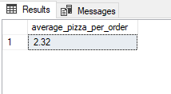

**--1) DAILY TRENDS OF TOTA ORDERS**

Analyzes daily trends in total orders by extracting the day of the week from "order_date" and grouping the results, providing valuable insights.

**select * from pizza_sales;**

**select DATENAME(DW, order_date) as order_day, count(distinct order_id) as total_orders**

**from pizza_sales**

**group by DATENAME(DW, order_date);**

**OUTPUT**

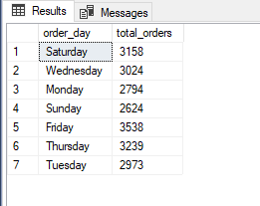

**--2) HOURLY TRENDS**

Analyzes order distribution by hour, counting distinct orders and sorting them in descending order. Useful for identifying peak demand periods.

**SELECT DATEPART(hour, order_time) AS order_hours, COUNT(DISTINCT order_id) AS total_orders**

**FROM pizza_sales**

**GROUP BY DATEPART(hour, order_time)**

**ORDER BY total_orders DESC;**

**OUTPUT**

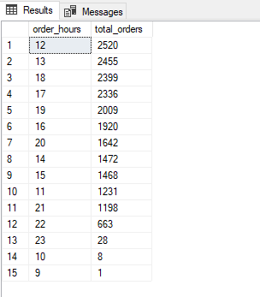

**--3) TOP 5 PICK HOURS**

The top 5 peak ordering hours by counting distinct orders and grouping them by hour, ordered by total orders in descending order.

**SELECT top 5 DATEPART(hour, order_time) AS order_hours, COUNT(DISTINCT order_id) AS total_orders**

**FROM pizza_sales**

**GROUP BY DATEPART(hour, order_time)**

**ORDER BY total_orders DESC**;

**OUTPUT**

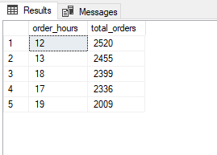

--**4) PERCENTAGE OF SALES by PIZZA CATEGORY:**

The total sales and percentage of sales for each pizza category. It groups the results by category and orders them based on total sales in descending order. Useful for analyzing sales performance by category.

**select pizza_category,cast(sum(total_price)as decimal(10,2))as total_sales,**

**cast(sum(total_price) * 100 /**

**(select sum(total_price)from pizza_sales)as decimal(10,2))as PCT**

**from pizza_sales**

**group by pizza_category**

**order by total_sales desc;**

**OUTPUT**

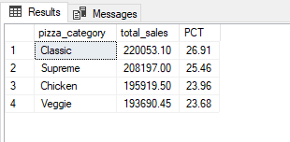

**--5)PERCENTAGE OF SALES by PIZZA SIZE:**

The total sales and percentage of sales for each pizza size specifically for the month of January. It provides insights into the sales performance by size during that specific month, ordered by total sales.

**select pizza_size,cast(sum(total_price)as decimal(10,2))as total_sales,**

**cast(sum(total_price) * 100 /**

**(select sum(total_price)from pizza_sales where month(order_date) = 1)as decimal(10,2))as PCT**

**from pizza_sales**

**--in where clause we can see that total sales on month of januray**

**where month(order_date)=1**

**group by pizza_size**

**order by total_sales desc;**

**OUTPUT**

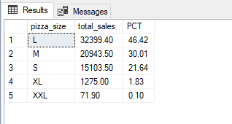

--**6) TOTAL PIZZA SOLD BY PIZZA CATEGORY**:

calculates and displays the total quantity of pizzas sold for each pizza category, ordered by the highest number of sold pizzas.

**select pizza_category,sum(quantity)as sold_pizza**

**from pizza_sales**

**group by pizza_category**

**order by sold_pizza desc;**

**OUTPUT**

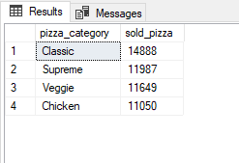

**--7)TOP 5 BEST SELLERS BY TOTAL PIZZA SOLD:**

The top 5 pizzas based on the total quantity sold, along with their corresponding category. It provides insights into the best-selling pizzas across categories.

**select top 5 pizza_name, sum(quantity)as total_pizza_sold,pizza_category**

**from pizza_sales**

**group by pizza_name,pizza_category**

**order by total_pizza_sold desc;**

**OUTPUT**

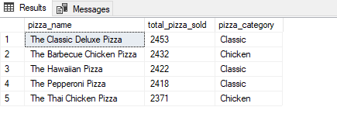

**--8)** **BOTTOM 5 WORST SELLERS BY TOTAL PIZZA SOLD:**

The top 5 pizzas based on the total quantity sold in the month of February. It provides insights into the best-selling pizzas during that specific month.

**select top 5 pizza_name,sum(quantity) as total_pizza_sold**

**from pizza_sales**

**where month(order_date)= 2**

**group by pizza_name**

**order by total_pizza_sold;**

**OUTPUT**

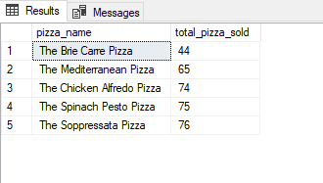

I am delighted to present the comprehensive documentation for my recent project on Pizza Sales Analysis. This project entails a meticulous examination of pizza sales data, aiming to derive critical metrics, trends, and insights that can empower businesses in the highly competitive food industry.

Through a systematic analysis of various facets such as total revenue, average order value, total pizzas sold, and daily sales trends, this project offers a profound understanding of the intricate dynamics within the pizza market. By leveraging advanced SQL querying techniques and data analysis methodologies, we have uncovered valuable insights to enhance decision-making processes and drive strategic growth initiatives.

Some of the noteworthy aspects covered in this project include:

1. Total Revenue Analysis:

- An in-depth exploration of the overall revenue generated from pizza sales, enabling businesses to assess their financial performance accurately.

2. Average Order Value Assessment:

- An examination of the average value of each pizza order, aiding businesses in understanding customer spending patterns and optimizing pricing strategies.

3. Total Pizzas Sold Evaluation:

- A comprehensive analysis of the total count of pizzas sold, providing insights into market demand and identifying potential growth opportunities.

4. Daily Sales Trends:

- A meticulous examination of daily sales trends, including peak ordering hours and patterns, to help businesses effectively allocate resources and meet customer expectations.

Moreover, this project delves into sales performance analysis by pizza category and size, shedding light on the best-selling products and identifying areas for improvement. By dissecting the intricate details of the pizza market, businesses can make data-driven decisions to stay ahead of the competition and foster long-term success.

I invite you to explore the detailed documentation of this project, which showcases the robust methodologies, sophisticated analytics techniques, and practical insights that can be leveraged to drive growth and profitability in the ever-evolving food industry.

Please feel free to reach out if you have any questions or require further information. Let's unlock the full potential of your business with this comprehensive Pizza Sales Analysis project.